WEEK 8 ASSIGNMENT
Contents
WEEK 8: HANDLING USER INPUT AND EVENTS: 2
IMPLEMENTING TOUCH GESTURES AND KEYBOARD INPUT HANDLING USING OBJECT-ORIENTED PROGRAMMING (CLASS-BASED APPROACH) 2
PRACTICAL ACTIVITIES UNDERTAKEN 2
TOOLS/SOFTWARE USED 3
PERSONNAL REFLECTION 3

WEEK 8: HANDLING USER INPUT AND EVENTS:

IMPLEMENTING TOUCH GESTURES AND KEYBOARD INPUT HANDLING USING OBJECT-ORIENTED PROGRAMMING (CLASS-BASED APPROACH)
Develop a class-based application that accepts keyboard input, detects touch gestures, logs events, and displays messages when interactions occur. Ensure all functionality is organized into separate classes and methods according to object-oriented programming principles.

PRACTICAL ACTIVITIES UNDERTAKEN
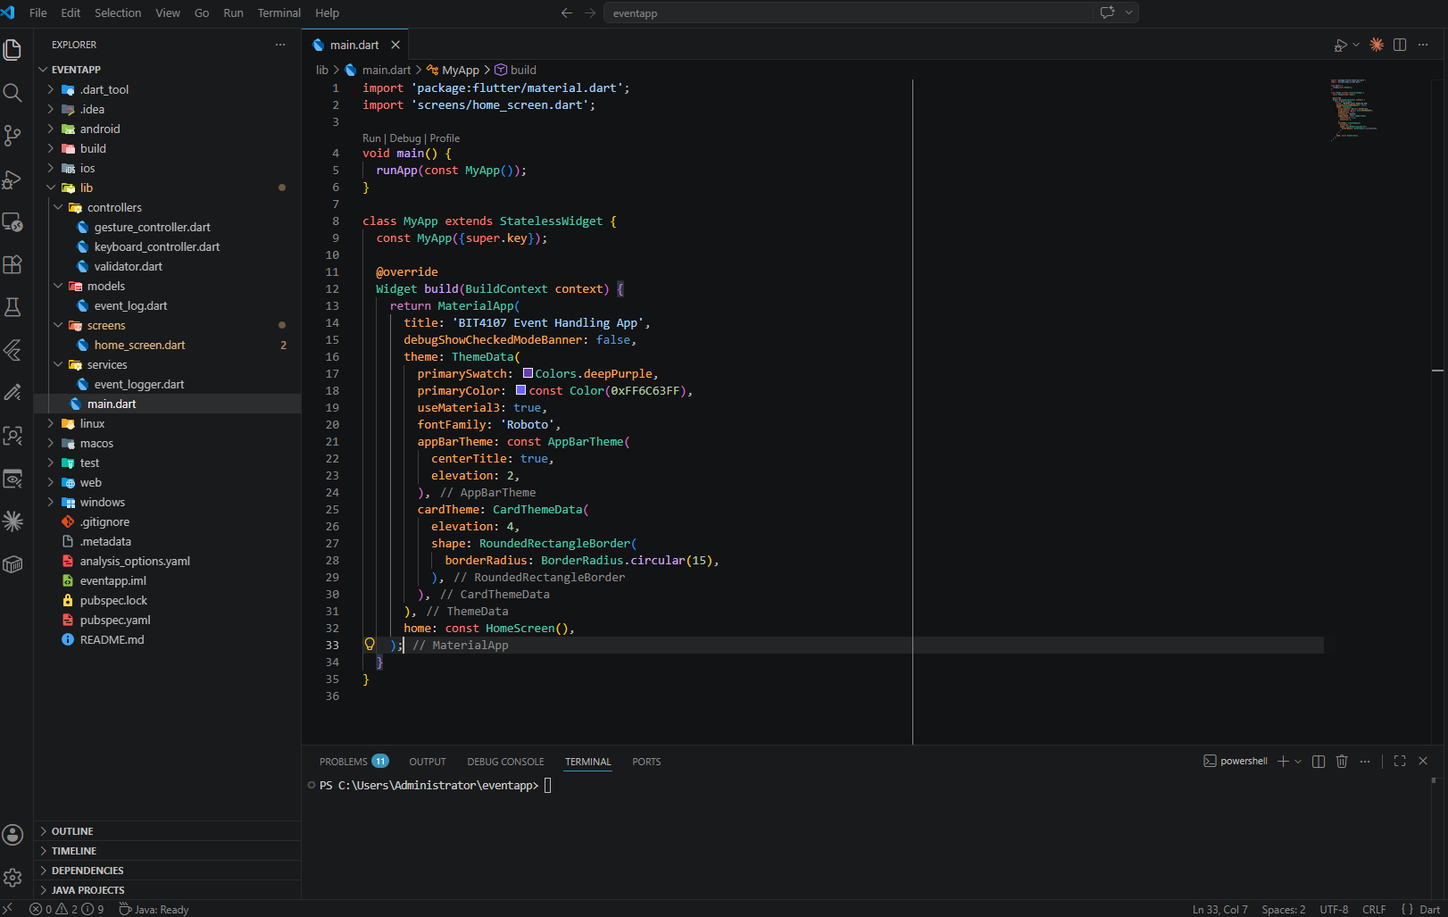
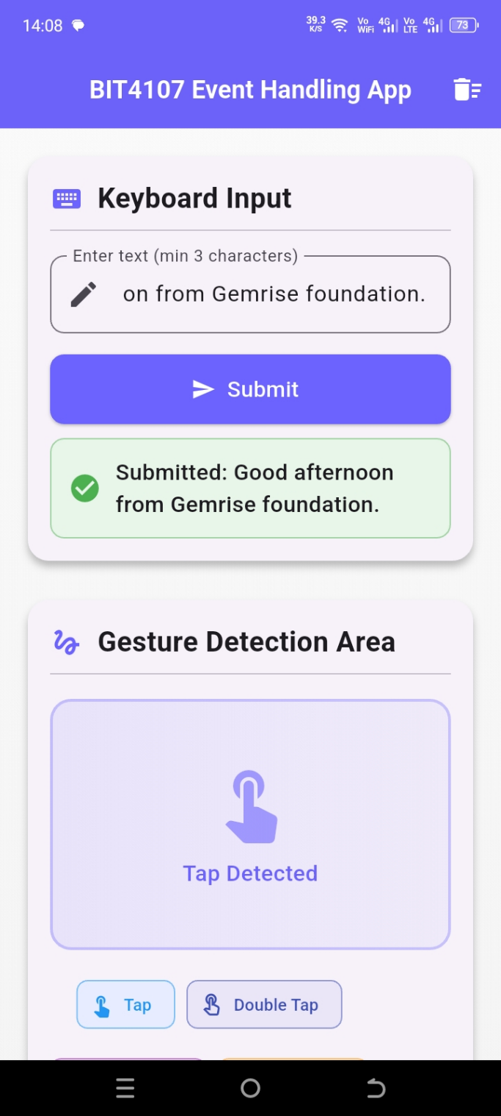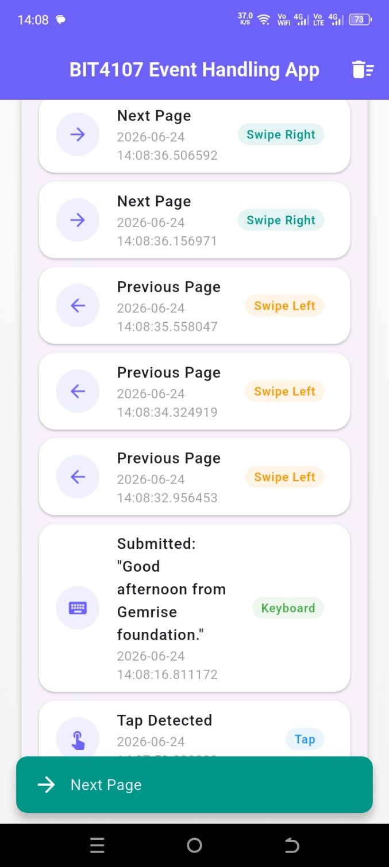

TOOLS/SOFTWARE USED
  - Flutter
  - VS code
  - Android studio

PERSONNAL REFLECTION
This task improved my understanding of event-driven programming in Flutter. I learned how to handle keyboard input, validate user data, detect touch gestures, and organize code using classes. It strengthened my object-oriented programming skills and showed me how user interactions improve mobile application functionality and user experience.

